RESUME

SAKET KUMAR SINGH
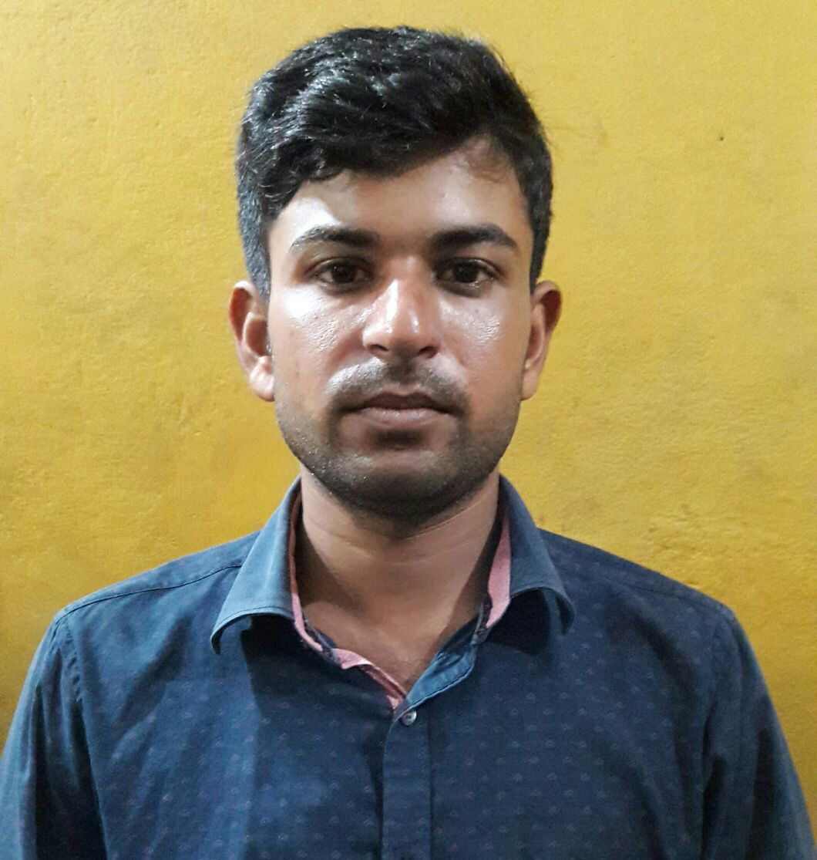
Date of Birth: - 12Apr 1992
S/O - Sri Vijay Kishor Singh
22/B Rajendra Mullick Street
Kolkata 700007 (W.B)
Mobile No-09681126063,08210892158
Email Id: - saketsingh257@gmail.com

Career Objective:-

- My Objective Is To Hard Work In My Working Field And Gives The Best Possible Output To My Organization.

Educational Qualification:-

- Matriculation 2nd from B.S.E.B Patna in 2007.
- Intermediate 1st from B.I.E.C Patna in 2009.
- B.A . Jai Prakash University in 2012.

Working Experience:-

Experience in Transport Service In Kolkata.From 2011…………

Permanent Address: - Vill- Pipra
PO-Sahajitpur
PS-Sahajitpur
PIN-841422
DIST-Saran

Nationality :- Indian

Marital Status:- Unmarried

Sex:- Male

Religion:-Hindu

Hobby:-Reading & Working

Language Known :- Hindi, English,Bengali

Declaration:-

I Hereby Declare That All The Information Is Maintained Above Is True To The Best Of My Knowledge.

Date:……………… ……………………
Place:……………… signature

