R E S U M E
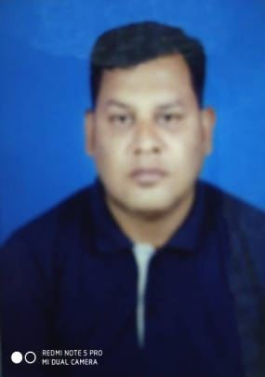

JIBESH CHANDRA PATI

S/O- Late Kailash Chandra pati

AT- Sarbodaya Nagar

Near Sai Temple, Puri

Odisha, 752002.

Mobile: 9178450285, 9861088913

Email- jibeshpati@gmail.com, jchandrapati@coca-cola.in

CAREER OBJECTIVE: -

To work with an organization that inspires Professionalism, where I can be an integral part of the management to grow with it by virtue of my skills, efforts & dedication.

Work Experience 1:  HINDUSTAN COCO-COLA BAVERAGES PVT LTD adecco(BBSR) Duration: NOV 2007 to DEC 2011
Designation: MARKET DEVLOPER
JOB RESPONSIBILITY
- Scheme operation and monitoring.
- Horizontal expansion
- Asset control and ownership
- Secondary-Red execution
- Cooler Purity& availability
Work Experience 2: HINDUSTAN COCO-COLA BAVERAGES PVT LTD Duration: JAN 2012 to TILL DATE
WORKING LOCATION: - GUNPUR
Designation: MARKET GROWTH EXECUTIVE
JOB RESPONSIBILITY
- Distributor and spoke management.
- Scheme operation and monitoring.
- Horizontal expansion
- Asset control and ownership
- Responsibility distributor primary and secondary .
- Competition tracking and monitoring.
- RED execution – Right execution Daily is a important part which includes availability of all our brand packs, visibility of our products, display should be properly going or not. Every month a team survey of red comes which gives scores of team members, this helps as to find out the problems of individual outlet.
- New business development
WORKED TOWN PREVIOUSLY BHUBANESWAR, PURI, BERHAMPUR.
Educational Background
- BA in 2007 at Balanga college, Balanga
- 2 Sc. in 2000 at Balanga college, Balanga
- H.S.C in 1998 at Biswambhar vidyapitha, Puri
Extra-curricular Activities & Hobbies.
- Singing & listening Music.
- Traveling & Biking long distance.
Personal Details

- Name: Jibesh Pati
- DOB: 02-Feb-1982
- Marital Status: Married
- Gander : Mail
- Nationality: Indian
Languages Known

- Hindi, Oriya, English,
Bengali

I hereby declare that, all the information stated above is true to best of my knowledge and believe.

Place: - Gunpur
Date – / JIBESH CHANDRA PATI

