CURRICULUM VITAE

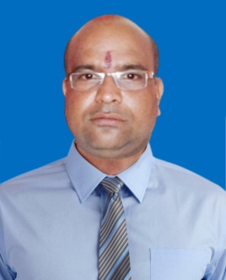
SUMANTA KUMAR MOHANTY
Plot No-EB/666, Badagada Brit Colony,
Bhubaneswar-751018, Odisha
Mob : 7326049951, 9040486845
Email : sumantamohanty7777@gmail.com
OBJECTIVE
To work in a dynamic and challenge driven environment that allows me to apply my skills an qualifications to the fullest for I believe there is nothing better than learning by experience and growing along with the Organization.
EDUCATIONAL QUALIFICATION :
- Graduate under Utkal University from B.J.B. College, Bhubaneswar.
- Management in Marketing from Institute of Management Education and Research (IMER), Madras.
WORK EXPERIENCE
- Kinetic Marketing & Services Ltd.
Sales Officer to Branch Manager (Aug-1999 to June-2005), BBSR.
- Mahindra & Mahindra Financial Services Ltd.
Asst. Manager Sales & Collection Car Finance,(July-2005-to May-2010),Keonjhar.
- Magma fincorp Ltd.
Asst. Manager to Sr. Manager C.V. Sales, (June-2010-Aug.2013), Jajpur.
- TATA Motors Finance Ltd.
Area Sales Manager C.V. (Sept.2013 to Feb-2018), Jharkhand.

- IDFC First Bank Ltd.
Regional Manager (Asst. Vice-President), (Mar.2018 to till date) Jharkhand & Chhatisgarh.
Managing the portfolio of Comercial Vehicles, Loan,
Managing both DSA vertical & open market and generating business through them.
Team : Handling area level marketing activities & ensuring business growth / target achieved.
Planning systematic abilities for smooth functioning of the team and developing cohesiveness within the company and co-workers.
Coaching mentoring and training employees & providing them with timely feedback on their performance, maintaining quality of business by tracking and controlling the team.
Guiding and motivating subordinates in achieving their goals.

BEST ACHIEVEMENT :
Kinetic Achievers Club (KAC)
- KAC-2000
- KAC-2001
- KAC-2002
- KAC Pride Award-2002
- Best Sales Branch in India, Target Vs. Achievement 2001
(Winner of Gold Medal)
- KMSL No.-1 Excellence in Sales - 2002.
PERSONAL DETAILS :
Name : Sumanta Kumar Mohanty
Father’s Name : Late Naba Ksihore Mohanty
Date of Birth : 15th Jun 1977
Marital Status : Married
Gender : Male
Nationality : Indian
Religion : Hindusim
DECLARATION :
I Sumanta Kumar Mohanty hereby declare that all statements made in this application are true, complete and correct to the best of my knowledge and belief.

Date : ……/……/………
Place : Bhbaneswar Sumanta Kumar Mohanty

