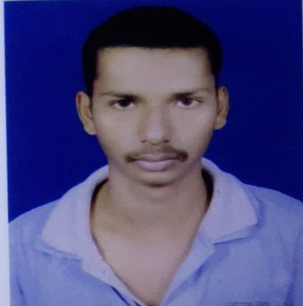
PERSONAL INFORMATION
Name: MUNA DWARI
Mother’s name: SANJU DWARI
Father’s Name: KALANDI DWARI
D.O.B: 03.06.1998
Religion: Hindu(SC)
Nationality: Indian
Email id: munadwari@gmail.com
Contact No: +91 9776907041
Employment Number: OD0112017533
Blood group: O(+VE)
ADDRESS
At/Po: Brahmanbil , P.S.: Chhendipada
Block: Chhendipada , Dist. : Angul
Pin : 759130
QUALIFICATION
Qualification | Year of passing | Institute Name | Board/University | Percentage/CGPA
Matriculation | 2013 | BRAHMANBIL HIGH SCHOOL,BRAHMANBIL | BSE | 51.5
Intermediate | 2015 | KANIHA JUNIOR COLLEGE,KANIHA | CHSE | 42
Diploma | 2017 | PCIET, CHHENDIPADA | SCTE & VT | 69
Graduation | 2020 | KANIHA DEGREE COLLEGE, KANIHA | UTKAL UNIVERSITY | 50

Courses
- Post graduate diploma in computer application(PGDCA)

STRENGTH
- Analytical thinking.
- Relationship building, Manpower management, Job supervision and teamwork.
- Execution of assigned job with time.
- Strong verbal and personal communication skills.
- Accuracy and Attention to details.

HOBBIES
- Playing outdoor games.
- Listening music
- Social Services.

