CURRICULUM VITAE

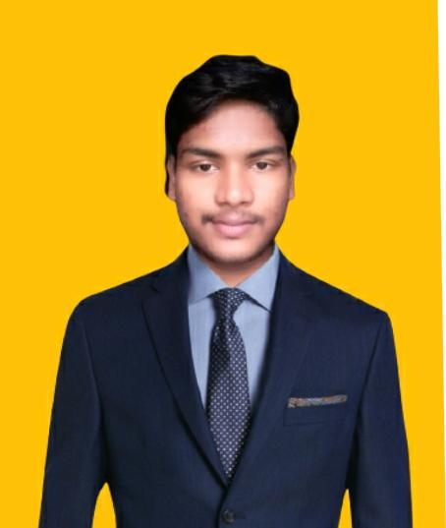
SANJAY KUMAR MOHALIK
B.TECH (MECHANICAL ENGG.)
Contact No:-9348415839
Email:-saisanjaypin2@gmail.com

CAREER OBJECTIVE
- To start and build a career in the field of Mechanical Engineering with my discipline and hard working skills.
PERSONAL SKILLS
- Ability to rapidly build relationships and setup trust.
- Confident and determined.
- Ability to cooperate with different situations.
- Team facilitator.
BASIC ACADEMIC CREDENTIALS

QUALIFICATION | SCHOOL/COLLEGE | UNIVERSITY | YEAR | TOTAL MARK %/CGPA
B.Tech  Mechanical engg. | MEMS,BLS | BPUT | 2019 | 7.83 CGPA
+2 science | Remuna jr. college | CHSE | 2015 | 51%
10th | Remuna high school | BSE | 2013 | 58%

COMPUTER SKILLS
- MS-WORD :- Basic formatting.
- MS-POWERPOINT:- presentation slides preparation.
- COMPUTER COURSE :- OS-CIT online computer course.
PROJECT EXPERIENCE
- Submitted project on 6th semester :- plasma arc machining.
- Submitted project on 8th semester:- Hydroelectric power plant.
PERSONAL STRENGTHS
- I am confident, enthusiastic, disciplined, have the ability to adapt to the available working environment, to work efficiently in a team and capability to produce time bound error free results. if given a chance I can light the candle in roughest of the weather.
PERSONAL DETAILS
Fathers name : Mr.Narayan mohalik
Gender : Male
Date of birth : 8th July 1998
Address : Harashpur, khirachora(756019), Balasore, odisha.
Language known : odia, hindi and English
Nationality/Religion :Indian/hindu
Marital status :single
Hobbies :Listening music

DECLARATION
I do here by declare that the above information is true to the best of my knowledge.

DATE: ____________
PLACE:____________ (SIGNATURE)

