Name: Anasua Chakraborty Goswami 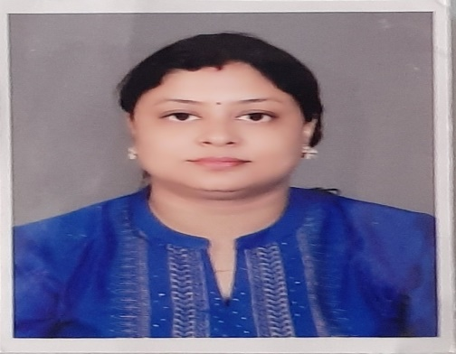

Mobile:7797601637/7980158619
E-mail:anasuagoswami09@gmail.com

Objective : I want to take greater responsibilities in organization so that I can utilize my skill and experiences effectively towards the growth of the organization and thus the objective of the organization and me can be fulfill.

Educationalqualification:-

Sl.No. | Name of the Exam | Board | Stream | Year of Passing
1 | MSW | Burdwan University | Women Empowerment | 2010
2 | Graduation | Burdwan University | Pol. Science | 2008
3 | Higher Secondary | WBCHSE | Arts | 2005
4 | Madhyamik | WBBSE | General | 2003

Work Experience :-
Name of the Organisation | Designation | Tenure | Place of Posting | Job Role
Arohan Financial Services Pvt Ltd | Branch Head | 14th August'2010 - 30th November'2011 | Raniganj | Maintaining Branch Portfolio, Generating Business, Recruitment
Ganges Jute Pvt.ltd | Store Manager | 01st December'2011 - 31st May'2012 | Shyamnagar | Maintaining Records on Daily Basis of Stocks.
Muthoot Fincorp Ltd | Branch Manager | 17th August'2012 - Till date | Bally,Chinsurah,Bandel | Maintaining Branch Portfolio, Generating Business

Personal Detail:-

Fathers Name : Lt. Somesh Kumar Chakraborty

Present & permanent address: 56/1, J.C.Khan Road, Mankundu, P.S-
Bhadreswar, P.O-Mankundu Pin-712139

Language known : a) Bengali.
b) Hindi.
c) English.
Date of birth: 11-06-1987

Marital status: Married.

Nationality: Indian.

Computer knowledge: Basic knowledge of Ms Office, familiar to Use internet.

Strength: Positive attitude, self Motivator, Leadership skills & Experience.

I do hereby declare that all the above information regarding myself is true and I will be fully responsible for any of the above information in future.

Date: Signature

