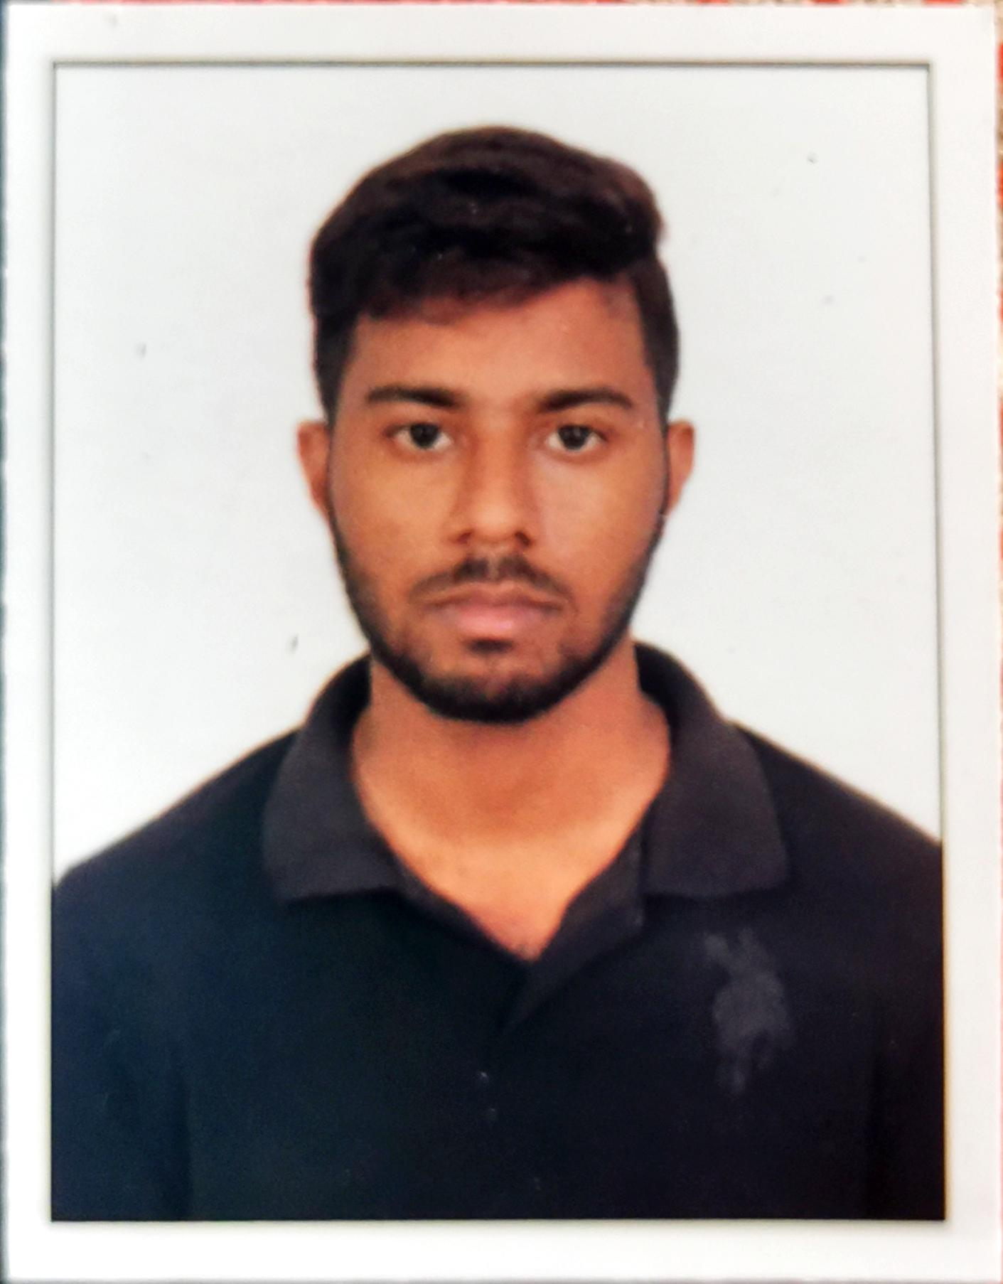

CAREER OBJECTIVE

RAVI ANURAG
Mother Teresa path,west Ramkrishna nagar,patna-27
+918826693604
rvanurag7775@gmail.com

Toobtainemploymentwithacompanythatoffersapositiveatmospheretolearnandimplementnewskillsand technologies for the betterment of theorganization.

EXPERIENCE

No experience I am a fresher

EDUCATION

  - Bsc biotechnology,YBN UNIVERSITY,ranchi,7.02 CGPA 2020

  - PATNA CENTRAL SCHOOL, Intermediate (CBSE)66% 2014

  - PATNA CENTRAL SCHOOL (CBSE)HIGH SCHOOL(10TH)
8 CGPA, 201

PERSONAL STRENGTHS

  - Communicative
  - ProblemSolving
  - Teamspirit

PERSONAL PROFILE

DateofBirth :05/03/1997
MaritalStatus :Single
Nationality :Indian
KnownLanguages : English, Hindi
Hobby : Travelling,Cricket,Watching Movies, To learn newthings

DECLARATION

I solemnly declare that all the above information is correct to the best of my knowledge and belief.

RAVI ANURAG

