RESUME
Mr. Rahul Karmakar  C/o Mr. Ramesh Karmakar  5/249 Gandhi Colony, PO Regent Estate,  PS Netaji Nagar  Kolkata – 700092  Ph. No- 9007071260  rahulkarmakar682@gmail.com | 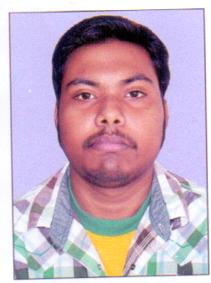  Rahul Karmakar
__________________________________________________________

EDUCATION DETAILS:
EXAMINATION | SCHOOL/COLLEGE | YEAR OF PASSING | BOARD/ UNIVERSITY
B. Com. (GEN) | KIIT | 2016 | Kalinga University
H. S | Tollygunge Ashoke Nagar Vidyapith | 2012 | W.B.C.H.S.E.
Madhyamik | Gandhi Colony Madhyamik Vidyalaya | 2010 | W.B.B.S.E.

Others
- Basic Computer knowledge
- Computer Typing

LANGUAGE KNOWN:
LANGUAGE | READ | WRITE | SPEAK
BENGALI | Yes | Yes | Yes
HINDI | No | No | Yes
ENGLISH | Yes | Yes | No

PERSONAL DETAILS:
Father’s Name : Mr. Ramesh Karmakar

Mother’s Name : Mrs. Kabita Karmakar

Date of Birth : 22/09/1993

Permanent Address : 5/249 Gandhi Colony (Tollygunge), Kol- 700092

Present Address : 5/249 Gandhi Colony (Tollygunge), Kol- 700092

Contact No : 9007071260

Nationality : Indian

Category : General

Religion : Hindu

I, hereby declare the above details furnished are true & correct to my best of knowledge & belief. If given a chance, I give my assurance that I would work to my full capabilities.


Date: 03.04.2017 ----------------------------
Place: Kolkata
RAHUL KARMAKAR

