CURRICULUM VITAE
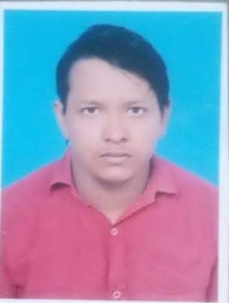
NAME :- KAMDEV KUMAR
MOB No :- +91-6207300723, +91-6206405363 EMAIL ID :- Kamdevkumar16@gmail.com
- Career Objective
I wish to undertake a challenging carrier and look forward to avail of opportunities, which would best my confidence to handle behavior responsibilities in future seeking a position that will utilize my talent to enhance the growth of the organization.
- Personal Skills
- Target oriented with excellent people of skill and ability to manage.
- Resourceful, innovative and flexible with good leadership qualities.
- Confidence and ability to learn fast and contribute.
- Believe in team work and good team player and can easily fit into any team.
- Educational qualification
- I passed Matric examination in 2007 with B.s.e.b Patna in2nd div.
- I passed Higher secondary examination (I.sc, B.s.e.b Patna in 1st div.) in 2009.
- I passed Graduation (B.sc, M.u Bodh Gaya, in 1st div) in 2012.
- Technical skill
- Computer : D.C.A,
- Diploma in Automobile engineering in Jamshedpur in 3years
- Personal details
- Name :- Kamdev kumar
- S/o :- Sri Brahamdev prasad
- D.o.b :- 12/02/1993
- Sex :- Male
- Marital Status :- Married
- Nationality :- Indian
- Religion :- Hindu
- Blood group :- “B+” (B, Positive)
- PERMANENT ADDRESS:-
- Village :- Akwalganj, post:- Sohsarai, p.s:- Rahui, Dist:- Nalanda, State:- Bihar, Pin:- 803118,
By considering the above, I humble request you to give me an opportunity to work in your esteemed organization, I assure you, sir, that I will do my best to satisfy you in all ways.

THANKING YOU,
DATE :- ……../……/…………..,
PLACE :- ………………………………..,
Signature

