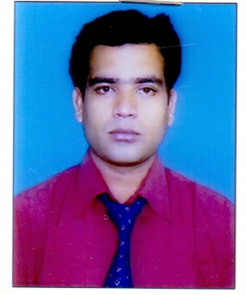
CURRICULUM VITAE

Bishnu Prasad Dash.
Bank Colony 1st Line Ext,
Berhampur,
Ganjam,Orissa.Pin no-760002
Cell No. – 0+91+9937538059,8763693122
CAREER OBJECTIVE

To assist myself with an organization where there is scope for contributing and organization served and seeking a career in challenging environment where my qualification, logical and creative skills are used to maximum.
EDUCATIONAL QUALIFICATIONS

- MATRIC (BrudabanaVidiyapitha )Hinjlicut.(1997).
- INTERMIDIATE (Hinjlicutscince college) Hinjlicut,Orissa. (2000).
- B.A (Hinjlicut College ) Hinjlicut,orissa . (2003).
- M.A (Pol.Sc In Berhampur University), Orissa .( 2007).

- M.B.A( FIANCE AND MARKETING) (Berhampur university) (2010).
CAREER OBJECTIVE

- Hardware Networking in TCIL-IT Berhampur Gandhi Nagar main road. (ADCNA-IT).

WORKING EXPERENCE

- Worked as TSI in HENZ INDIA PVT LTD from CUTTACK HEAD QUTER.( 20 jan 2007 to 5 feb 2010).
- Worked as ISR in GODREJ CONJUMER PRODUCT PVT LTD from KHORDA HEAD QUTER..( 15feb 2010 to 2 Sept 2012).
- Worked a ASM in RISTA FOODS PVT LTD from BERHAMPUR HEAD QUATER.( 10 Sept 2012 to continue ).

PERSONAL DETAILS

1. Name : BISHNU PRASAD DASH
2. Father’s Name : Sri.Bijay Kumar Dash
3. Permanent Address : Bank Colony 1st Line Ext,
Berhampur,
Ganjam,Orissa.
Present Address : Bank Colony 1st Line Ext,
Berhampur,
Ganjam,Orissa.
4. Date of Birth : 10-07-1982
5. Marital Status : Un-Married.
6. Nationality / Religion : Indian / Hindu.

7. Languages Known : English, Oriya & Hindi.
8. Hobbies : Listening music.

9. Strength : My Guardians.

10 . E-Mail ID : mrbishnuprasaddash@gmail.com
DECLARATION

I do here by declare that the details furshined above are true and best of my knowledge and beliefs.

Date : 07/09/2019 Bishnu Prasad dash
Place : Berhampur (BISHNU PRASAD DASH)

