Name : Prokash Shil
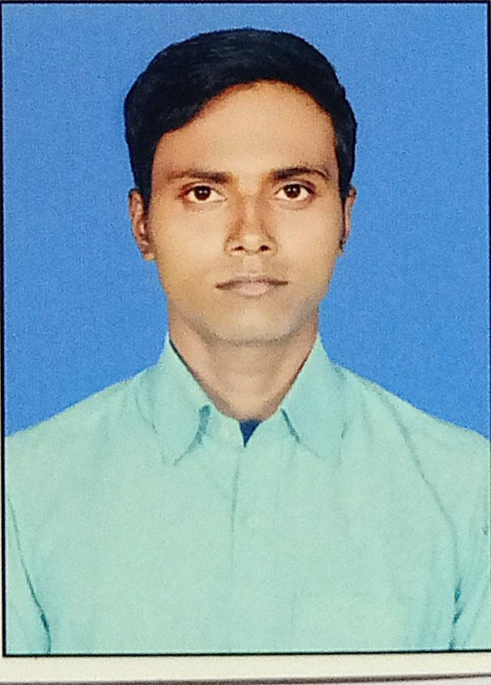
Mobile: +917003924059
Email: prokashshil1995@gmail.com
Address: Bishpara(2),Nayasari,Mogra, Hooghly,
West Bengal, 712513

CAREER OBJECTIVE
To be a part of an organization where I could be able to prove my self worthy by implementing my skills and efficiency towards the growth of the organization.

EDUCATIONAL QUALIFICATION
Examination Name | Board Name | Year of Passing | Division
10th | WBBSE | 2011 | 2nd
12th | WBCHSE | 2013 | 2nd
B.Sc(Geography Hons.) | NSOU | 2020 | 2nd

CERTIFICATE COURSES
Name of the Course | Duration | Conducted by
Computer Application | 12 Months | WBSCTVESD

WORK EXPERIENCE
Name of the Organization | Duration | Date | Job Role
Justdial | 8 Months | 18/10/2021- 18/06/2022 | Tele Marketing Executive

IT SKILL
- MS Office Language: MS Word, PowerPoint,Excel
- Operating System: Windows

EXTRA CURRICULAR ACTIVITIES
- Participating Blood Donation Camp as a volunteer .
- Playing sports.
My Strength | My Weakness
- Self-Motivator | 1. Being very easily trusted to Others.
- Quick Learner and Accuracy | 2. I was never a bookworm.
- Hard Worker

LANGUAGES KNOWN
English: Read / Write / Speak
Hindi: Speak/Read
Bengali: Read / Write / Speak

PERSONAL DETAILS
Name : Prokash Shil
S/O : Nirmal Shil
Date of Birth : 20th May 1995
Gender : Male
Marital status: Unmarried

I hereby declare that all the above mention statement is true to my knowledge. No attempts have been made falsify.

Place:

Date
----------------------------------------------
Signature

