CURRICULUM VITAE
NAME : SANJIT BHOWMICK.
MOBILE NO : 8670032470 / 7980105404
PERSONAL DETAILS:
FATHER NAME : ASTO BHOWMICK
PERMANENT ADDRESS : VILL – CHAKDAHA, P.O.-HANSURY, P.S.- USTHI, DIST, SOUTH 24PGS,
WEST BENGAL, PIN – 743 609.
RELIGION : HINDU
SEX : MALE
DATE OF BIRTH : 15/11/1992
NATIOLITY : INDIAN
MARITAL STATUS : UNMARRIED.
CAST : GENERAL.
LANGUAGE KNOWN : BENGALI, ENGLISH & HINDI.
EDUCATIONAL QUALIFICATION
PASSED SECONDARY EXAMINATION 2003.
COMPUTER SKILLS
BASIC KNOWLEDGE.
EXTRA QUALIFICATION
DIPLOMA IN MEDICAL LABORATORY TECHNOLOGY (DMLT).
EXPERIENCE
WORKED IN LIFELINE NURSING HOME WITH LABORATORY AS PHLEBOTOMIST FROM 2006 TO 2010 AND ALSO RETAIL EXPERIENCE 4 YEARS IN MEDICINE SHOP.
ALLASIA AS A PHLEBOTOMIST FROM 08/07/2011 TO 01/12/2014.
APOLLO CLINIC SOUTH CITY AS PHLEBOTOMIST FROM 02/12/2014 TO 01/12/2017.
FUTURE CLINIC AS PHLEBOTOMIST FOR THREE YEARS.
ACCUHEALTH DIAGNOSTICS AS PHLEBOTOMIST FOR 1 YEAR.

DATE :
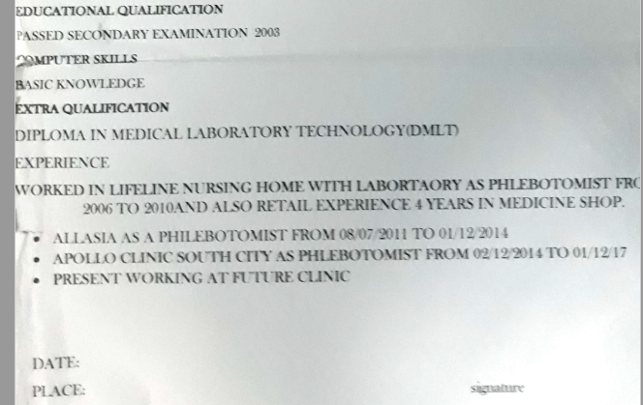
PLACE : SIGNATURE

