CURRICULUM VITAE
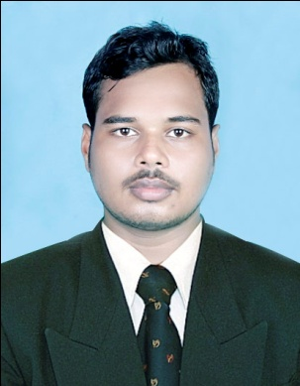
MRUTYUNJAYA PANDA
PROFESSIONAL EDUCATION
COMPLETED BACHELOR OF TECHNOLOGY IN ELECTRICAL & ELECTRONICS ENGINEERING
(2016-19) from SRINIX COLLEGE OF ENGINEERING, BALASORE, ODISHA
PERSONAL QUALIFICATION
Board/University/Institute | Degree | Year | Marks | % of marks
Board of Secondary Education, Odisha | HSCE | 2008 | 333 | 41%
State Council Of Technical Education & Vocational Training, Odisha. | I T I IN ELECTRICIAN | 2011 | 594 | 84%
Gyanadeep Computer Education | P.G. D. C. A | 2011 |  | 75%
State Council Of Technical Education & Vocational Training, Odisha. | DIPLOMA IN ELECTRICAL ENGINEERING | 2013 - 15 | 1st sem. 195  2nd sem. 115  3rd sem. 472  4th sem. 429  5th sem. 442  6th sem. 498 | 61%
BIJUPATNAIK UNIVERSITY OF TECHNOLOGY, ROURKELA, ODISHA. | BACHELOR OF TECHNOLOGY IN ELECTRICAL & ELECTRONICS ENGINEERING | 2016 - 19 | 3rd &4th Sem  5th & 6th Sem  7th & 8th Sem | 64.20%  63.80%  65.70%

Personal profile
Name : MRUTYUNJAYA PANDA
Father’s Name : BENUDHAR PANDA
Date Of Birth : 26th may. 1992
Nationality : Indian
Religion : Hinduism
Marital Status : Married
Sex : Male
Community : General
Language Known : Oriya, Hindi, English
CAREER OBJECTIVE
To understand the environment of corporate world and to implement my knowledge and working skills thereby contributing in the gain and growth of the organization and mine in the field.
Strengths
- Believe in myself
- Hardworking Nature
- Patience
Hobbies
- Reading Newspaper
- Interaction with people
- Playing Cricket
- Listening music

CONTACT ADDRESS
- MRUTYUNJAYA PANDA
- C/O- BENUDHAR PANDA
- At-Basubrahmapur
- Po-Nachinta
- Dist- Balasore
- Pin- 756043, ODISHA
- Contact no – 9348970195 & 9040866693
- E-mail ID – WWW.mrutyunjaya9040@gmail.com

DECLARATION
I solemnly hereby declare that all the information provided above is authentic to the best of my knowledge and belief .

Date :……………………………………..
Place :……………………………………. Signature

