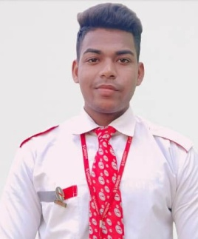
SUBHAKANTA SAMANTARAY
Subhakantasamantaray28@gmail.com
8260541756
TIME- OFF
- Listening songs
- Gym Workout
- Bike Riding
PERSONALITY TRAITS
- Punctual
- Hard-working& energetic
- Honest
PERSONAL DETAILS
Father’s name :Bijaya Kumar Samantray
Date of Birth : 28th February,2003
Height : 170 cm.
Weight : 65 kg.
Eye sight : Normal
Address : Ratamati,Jankia
Khordha
Odisha 752020
Passport : V3443706
Place of Issue : Bhubaneswar
Date of Issue : 30/11/2021
Date of Expiry : 29/11/2031
Aadhaar No. : 6843 7066 0363

CAREER OBJECTIVE
To be a part of the organization where I am motivated to welcome challenges and my knowledge & skills to archive my goal.

ACADEMIC QUALIFICATIONS
Course(Stream)/  Examination | Board/University | Year of Passing | Score
Higher Secondary | CHSE, Odisha | 2020 | 50.33%
Secondary | BSE, Odisha | 2018 | 51%

PROFESSIONAL QUALIFICATION
Course | Institution | Score
Diploma in Hospitality, Travel and Customer Services. | Frankfinn Institute of Air Hostess Training. | Completed

EXTRA CURRICULAR ACTIVITIES

- Very Much Pushups workout

Date:
Place: ---------------------
(Subhakanta Samantaray)

