
SANJIB MOHANTA
Address: Vill -Bakshipara, P.O- Mohitnagar, Dist. - Jalpaiguri, Pin- 735102

Career Objective: To secure a challenging position in a reputable organization to expand my learning, knowledge, skill, and my experiences.
Professional Qualification:

Degree | University | College | Result |  | Specialization | Year
Degree | University | College | Sem | CGPA | Specialization | Year
BBA | RAIGANJ UNIVERSITY | Eastern Institute for Integrated Learning in Management | 6 | 9.75 | Marketing Management | 2021
BBA | RAIGANJ UNIVERSITY | Eastern Institute for Integrated Learning in Management | 5 | 8.75 | Marketing Management | 2021
BBA | RAIGANJ UNIVERSITY | Eastern Institute for Integrated Learning in Management | 4 | 9.08 | Marketing Management | 2021
BBA | RAIGANJ UNIVERSITY | Eastern Institute for Integrated Learning in Management | 3 | 7.85 | Marketing Management | 2021
BBA | RAIGANJ UNIVERSITY | Eastern Institute for Integrated Learning in Management | 2 | 5.60 | Marketing Management | 2021
BBA | RAIGANJ UNIVERSITY | Eastern Institute for Integrated Learning in Management | 1 | 5.92 | Marketing Management | 2021

Exam | Board/Council | Trade | Percentage | Year
10+2 | West Bengal Council of Higher Secondary Education | Arts | 78.8 | 2018
10 | West Board of Secondary Education | NA | 43 | 2016
Strong Point:
- Team Player.
- Good Negotiation Skill
Academic Qualification:
- Good Communication Skill.
- Excellent Presentation Skill
- Punctuality.
Extra Curriculum Activity:
- Competed in Science Fair arranged by Rastriya Madhyamik Shiksha Avijan & Sarba Siksha Mission in Class 9.
- Computer Course ( certificate in information technology application)
- Digital Marketing Advantage Work Shop
:
Social Activity
- Working with NGO.
- Blood donation.

- Understanding Marketing Strategy of Backyard Poultry Farming in West Bengal.
Hobbies:
Final year project:
- Listening to music
- Talkative
- Singing
- Travelling by cycle.
Personal Information:
DOB: 02th December, 1999
Nationality: Indian
E-mail id: sanjibmohanta19@gmail.com
Mobile No: +91 6296862575, +91 7063516960

I Acknowledge that all the above information are correct and true as per my knowledge and belief.

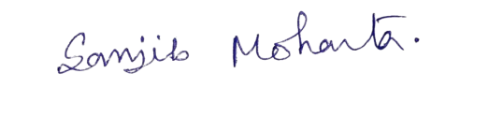

Signature

Date: 03/08/2022 Place: Jalpaiguri

