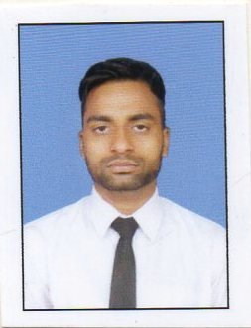

Name : Ashik Khan

Present Address : Vill – Sonarpur Noya Para, PO + PS – Sonarpur
Kolkata – 700150, Near Sonarpur Railway Station

Permanent Address : Vill - Baladebpur, PO – Ramakantanagar,
PS – Mandirbazar, Dist – South 24 Parganas, Pin – 743395, West Bengal

Contact No : 9547757601
E-mail id : khanashik0071@gmail.com

Career Objective :
To work with dedication and sincerity in an organization so that I can expand my skills and also contribute to the overall growth of the company.

EDUCATION PROFILE ::
Name of Examination | Board | Year of Passing
Higher Secondary | DELHI BOARD | 2013
Madhyamik | WBBSE | 2011

Extra Qualification :
- Basic Knowledge of Computer.

Work Experience :
- Work as at Khosla Showroom for 6 months.

Personal Details :
DATE OF BIRTH : 07.10.1993
FATHER’S NAME : MUNNA KHAN
RELIGION : ISLAM
GENDER : MALE NATIONALITY : INDIAN LANGUAGES KNOWN : BENGALI, ENGLISH & HINDI MA RITAL STATUS : UNMARRIED

DECLARATION :
I have declared that all the particulars furnished by me in application this is true correct and complete to the best of my knowledge and belief.

Date - Signature

