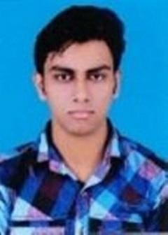
CURRICULAM VITAE

Name: Sourav Chakraborty

Contact : +918777748400
E-mail : chakrabortysourav1391@gmail.com
Linkedin: https://www.linkedin.com/in/sourav-chakraborty-6a4322175

PROFILE

- Hard-working, multi-tasking Executive Assistant documentation skills.
I use a creative approach to solve many problems. I am always energetic and eager to learn new skills.

WORK EXPERIENCE

2018- 2019 :

2019- 2022 :
Modern Homoeo Distributor.
as a Computer Operator.

Globsyn AI Workspace
Quality Analyst, Kolkata (3 years experience). Mainly project was annotate raw data for Machine Learning.

EDUCATION

2008 -2009 : Madhyamik Examination
Purba Barasat Adarsha Vidyapith, Barasat.

2010 - 2011 : Higher Secondary Examination
Purba Barasat Adarsha Vidyapith, Barasat.

2011 - 2015 : Graduation in History Hons
Barasat Govt. College.

2016 - 2018 : Masters in History
RBU University.
EXTRA

- Diploma Certificate in Information Technology Application from Youth Computer Training Center (W.B).
- D.T.P Certificate from Youth Computer Training Center (W.B).
- Good knowledge of MS-Excel, MS-word, MS-power point.
- Handling Google Drive (G-sheet, G-Doc).
- RNR from Last Company for Best Employee.
- IBM certificate basic computer course.
PERSONAL INFORMATION

Birth-Date : 13-01-1993
Gender : Male
Residence : Barasat, North 24 Parganas, Kolkata-700124
Nationality : Indian
Hobbies : Cricket, Cooking, Traveling, Writing.

Communication Skills : Can communicate by reading, writing in English, reading, writing & speaking in Bengali, and speaking in Hindi.

I hereby declare that the above furnished information is true to the best of my knowledge and belief, if given a chance, I can prove myself.

Date:
Signature

