CURRICULUM – VITAE

NAME - Suvashis Behera

C/O - Gyanendra Behera

AT - Sianroi

PO - Uplat

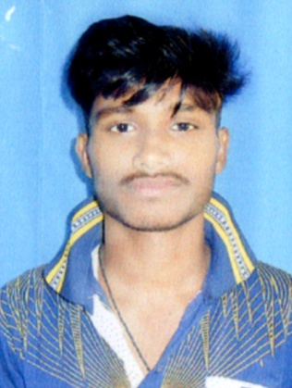
VIA - Kamarda

PS - Kamarda

DIST - Balasore

PIN - 756035

MOB - 9348809844

7381973886

E-MAIL – suvashisb358@gmail.com

OBJECTIVE :

To be associated with a progressive organization that give scope to apply my knowledge and skills and to be a part of team that dynamically works towards the growth of organization.
ACADAMIC QUALIFACITION

Examination Passed | Board/University | Year of Passing | Division | Percentage of Marks
10th (Metric) | B.S.E. Odisha | 2018 | First | 73%
+2 Arts | C.H.S.E. Odisha | 2020 | Third | 35%

KNOWLEDGE OF COMPUTER :

- Windows, MS Office, Internet, PGDCA, Tally.

HIGHLIGHTS :

- Through Excellent communication, Interpersonal and Problem solving skill.
- Able to work independently or within a team.
- Work a well under pressure.
- Ability to communicating with others.

PERSONAL INTEREST :

- Reading Newspaper, Listening Music and Interacting with new personalities.

PERSONAL INFORMATION:

Father’s Name : Gyanendra Behera
Sex : Male
Date of Birth : 05thFeb 2002
Marital Status : Single
Religion : Hindu
Nationality : Indian
Languages known : Oriya, Hindi, English & Bengali
Extra Curricular Activities : Reading News paper & Collecting Software.

DECLARATION:

I hereby declared that the information’s given is true about my knowledge & any false is occurred I am ready to face the consequence of the same.

Suvashis Behera

Date: Signature of the Candidate
Place :Balasore

