CURRICULUM VITAE
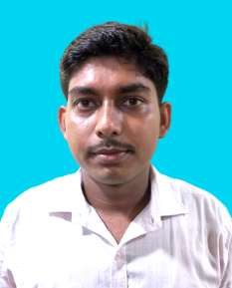
AMIT MANNA
Communication Address:
Vill- Hara (Dakshin)
P.O- Brahmanpara
P.S.- Haripal, Dist- Hooghly
Pin- 712405 (West Bengal)
Mob- 8420130060 / 9051887339
Email – amitmannahpl@gmail.com

Educational Qualification:
Sl. No | Exam | Board Of Examination | Year Of Passing | Division/Grade | Percentage | Stream
1 | M.P | W.B.B.S.E | 2014 | B | 35.71% | ---------
2 | H.S | W.B.S.C.V.E.T | 2016 | B+ | 58.17% | Vocational

ITI | 1st Sem Marks | 2nd Sem Marks | 3rd Sem Marks | 4th Sem Marks | 5th Sem Marks | 6th Sem Marks
ELECTRICIAN | 497 | 535 | 478 | 488 | ------- | ------
DIPLOMA (ELECTRICAL) | ----- | ----- | 72.2% | 77.4% | 61% | 72.1%

Career Objectives:
To be familiar with hard working in a competitive industry and to obtain an Electrical and Electronics Engineering position and challenging career in the any field.
Professional Qualification:
Computer Basic Knowledge.
Experience:
3 years’ experience in Sales & Marketing and 2.5 years’ experience in WBSEDCL sub-station operator.
Personal Profile:
Father’s Name: Arun Manna
Date Of Birth: 05.11.1998
Hobby: Playing Cricket
Gender: Male
Marital Status: Unmarried
Caste: Unreserved
Religion: Hinduism
Nationality: Indian
Language Known: Bengali – Hindi - English

Place: Hara
Date : Signature

