BIO – DATA
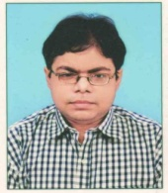
Name :: RANA SHARMA.

Father’s Name :: Shri Kartick Sharma.

Date of Birth :: 14.05.1989

Address :: 13/11, Barisha Purba Para ( School Road)
P.O:- Thakurpukur, P.S:- Haridevpur,
Kolkata – 700063.

Contact No :: 9903722128.

Email id :: sharmarana97@gmail.com

Educational Qualification ::

Exam Passed | Year of Passing | Board / University | Percentage of Marks (%)
AISSE | 2005 | CBSE | 51.8
AISSCE | 2007 | CBSE | 57.8
B.COM | 2010 | C.U. | 40.2
M.COM | 2016 | V.U. | 41.8

Skills :: a) Certificate in “ Ms-office” from ‘NIIT’
Behala Chowrasta on 2003.
b) Certificate in “ Tally ERP9” from
Aptech pvt ltd on 2018.

Nationality :: Indian.

Sex :: Male.

Marital Status :: Un-married.

Languages known :: English, Hindi, Bengali.

Hobbies :: Music & Travelling.

Date: 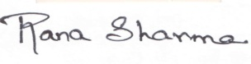
Place: Kokata-63. ___________________________
(SIGNATURE)

