ROHIT ANAND
Vision and Objective :
To work in an environment where my knowledge and management skills are effectively utilized and assure productive services which will satisfy the organization.
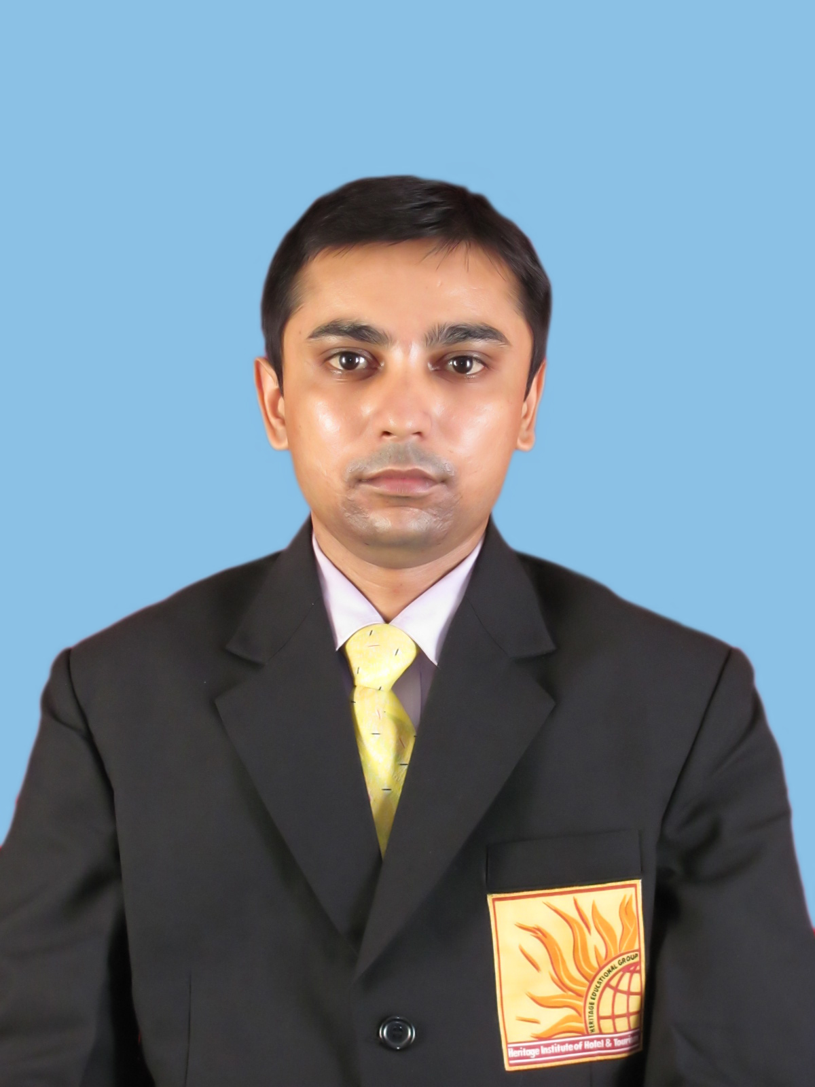
Personal Details

Name : Rohit Anand
Date of Birth :- feb-28-1986
Nationality :- Indian
Email address :- rohitanandranchi02@gmail.com
Contact Number :- +91-8340232548,9096092206
Father's Name :- Binay Kumar Sinha
Advocate (Jharkhand High Court Ranchi)
Mothers Name :- Manju Sinha

PRESENT ADDRESS :

Kill Burn Colony
Beside Shri Nilay Apartment
House No # 114
Hinoo, Ranchi
State# Jharkhand
Pin # 834002

Academic Projects:-
6 Months Industrial Training from Vivanta By Taj Panjim, GOA in 15th october 2010 to 15th march 2011.

Academic Credentials:-

YEAR- 2009 To 2012
Completed three year degree course of Integrated B.SC in Hotel Management Catering Technology & Tourism from Heritage Institute Of Hotel & Tourism, Goa , Certified Institution Punjab Technical University,Jalandhar.

I Have Also Completed Certified Course Of Retail Management & Aviation From Heritage Institute Of Hotel & Tourism Vasco Da Gama,GOA.

10+2 :- YEAR 2005
From Doranda College Ranchi, Jharkhand

10th :- YEAR 2002
R.K High School Jasidih, Jharkhand

EERINCE : 3 Years Experince In Front Office Department In
Kamakshi Hotel Vasco Da Gama, GOA.

I Have Completed 1 Year Experience In Hotel
Lord's Inn In Front Office Department As Front Office
Associate At Saputara DISTT # Dang, Gujarat.

Worked From 16 th April 2018 To 14 th January
2019 At Hotel Green Horizon In Front Office
Department in Ranchi.

I Have Worked From 18 th January 2019 To 31 st
December 2020 At Hotel Radisson Blu Ranchi,
Jharkhand

Completed On Job Training Program in Human Resourse
Department From Hotel Radisson Blu, Ranchi,
Jharkhand.

Completed MBA In HR From Ranchi University, Ranchi,
Jharkhand.

HOBBIES
- I love Watching Movies & listening good music and songs

LANGUAGE KNOWN:- English and Hindi

DATE :
PLACE: ROHIT ANAND Signature:

