CURRICULUM VITAE

Name – ASHOK KR SINGH

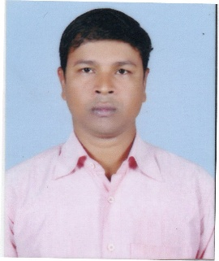  Mob:  9749825650  E-mail:  ashoks725@gmail.com  Address:  VILL- Club Road  P.O.- jalpaiguri  P.S. - Kotwali  DIST Jalpaiguri  PIN-735101  Date of Birth:  20/05/1985  Father’s Name:  Majindar Singh  Sex:  Male  Marital Status:  Married  Nationality:  Indian  Caste:  ST  Hobbies:  Recitation, Reading Book  Listening song, watching  Motivational Videos  Languages of  Communication:  English, Hindi, Bengali,  Nepali | Career Objective:  Seeking an entry level ion in an organization to exhibit strengths and enhance skill by utilizing myself as a resource for all kind of challenging jobs and upgrading my knowledge and skills in time, while striving for the growth and development of this organization.  Academic Qualifications:  Professional Qualifications :-M.B.A (Finance)  Computer Proficiency:Diploma in Financial Accounting System ( Ms. Office,  Excel, Power Point, Internet), Tally etc.  Experience:  - Sks Micro Finance Pvt LtdApril 2009 to August 2012.  - Life Cell Internation Pvt Ltd November 2012 to February 2014  - Cryo Banks international Pvt Ltd. May 2014 to December 2016.  Working Area – Siliguri, Coochbehar, Alipurduar, Islampur, Kishanganj  Katihar, Purnea,  - (Ramkrishna I.V.F. Test Tube Baby) Feb 2017 to November 2018  Working Area – Siliguri, Coochbehar, Alipurduar, Islampur, Kishanganj  Katihar, Purnea, Darjeeling  4. Nova ivf fertility Pvt Ltd December 2018 to till know  Strengths:  Ability to work in close coordination with all the members of a team and to be honest with my work and responsibility  Dedication towards work, hardworking, self-confidence, patience, and learning continuously
  Degree/ Certificate | Examination | Institute | Board/  University | Year  of passing
  Graduation | B.Com | Ananda Chandra College of Commerce | North Bengal University | 2007
  12th | Higher Secondary | Chengmari T.E. High School | West Bengal Council of Higher Secondary Education | 2004
  10th | Madhyamik | Chengmari T.E. High School | West Bengal Board of Secondary Education | 2002

Declaration:
I hereby declare that the above-mentioned information is correct up to my knowledge and I bear the responsibility for the correctness of the above-mentioned particulars.

Place : Jalpaiguri -------------------------------------------------------
Date: Signature

