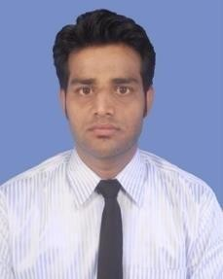
RESUME

SUBHAMOY MUKHERJEE
Contact no. : +91-9732193294
E-mail: subhamoyjee@gmail.com
-:CAREER OBJECTIVE:-

To work in a team in challenging and dynamic environment with maximum utilization of my skills and knowledge for continuous improvement and achievement of the vision of the Organization.
-:ACADEMIC QUALIFICATION:-

EXAMINATION | BOARD/ UNIVERSITY | YEAR OF PASSING | PERCENTAGE (%)
B.A. HONS | N.S.O.U | 2012 | 55 %
HIGH SECONDARY | W.B.C.H.S.E | 2008 | 57.8 %
SECONDARY | W.B.B.S.E | 2006 | 60 %

-:PROFESSIONAL QUALIFICATION:-
Completed Computer basic course from WEBEL.
Completed Hardware and Networking Professional course from JETKING KOLKATA.

-:TECHNICAL SKILL:-

Operating System : - Windows 11, Windows 12. Server and client O.S

Networking : - Network setup, Outlook Configure, Wireless Networking, DHCP, DNS

MS Office :- MS Excel, MS Word, MS Power point.

-:WORK EXPERIENCE:-

Worked as a Data Entry Operator in Kamalpur Rural Development Society Between 2010-2013. Worked as a Operation Executive in TCS ION from October, 2018 to October,2021.
Working as a Computer Trainer in NATIONAL BOARD OF COMPUTER EDUCATION, Purulia from Nov 2021
PERSONAL DETAILS:-

Father’s Name : - Swapan Mukherjee

Mother’s Name :- Namita Mukherjee

Date of Birth : - 26/03/1991

Sex : - Male

Marital status : - Single

Nationality : - Indian

Languages : - English, Hindi, Bengali

Hobbies : - Playing Cricket & Football, Watching Movies

Permanent Address : - Saldiha, Chhatna, Bankura, Pin- 722139

I hereby declare that all the above information provided by me is true.

DATE: - Full Signature

PLACE: - Bankura …….……………………………………….
(SUBHAMOY MUKHERJEE)

