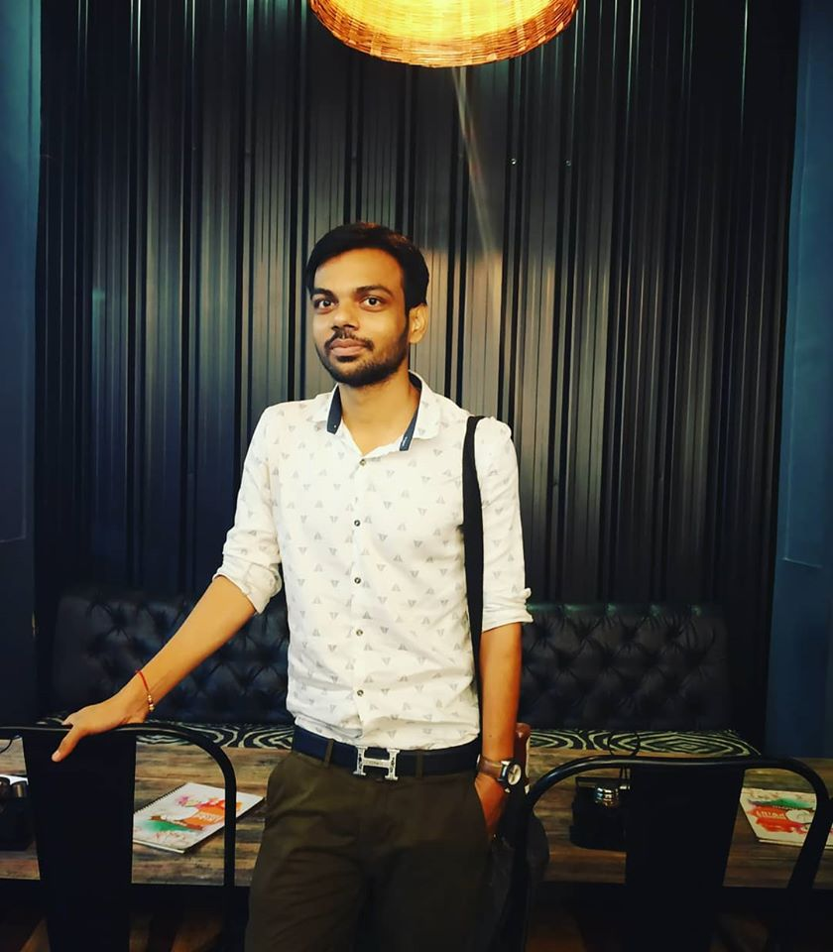 |  | nishant singh  Business Developer (sales)
Profile  Experienced growth marketing manager with a background in sales. Looking to leverage 2+ years of experience.  Date of Birth: 22/12/1994  Marital Status: Single  Nationality: Indian Known  Languages: English/Hindi  Contact  PHONE:  9711726735  EMAIL:  nishantsingh4698@gmail.com  Hobbies  Playing football  Blogging  Traveling to New place  Love to taste the different food  SKILLS  M.S OFFICE  DIGITAL MARKETING  CUSTOMER REALTIONSHIP |  | CAREER OBJECTIVE  To work for an organization which provides me the opportunity to improve my skills and knowledge to growth along with the organization objective. An enthusiastic business developer with highly motivated and leadership skills having bachelors of commerce degree, expert in Marketing.  EDUCATION  Satya Prakash public school  2012  [I completed my 12th with 64%. In school I was the football captain. I was also awarded by highest score in single match]  Institute of information management and technology  2015 – 2018  [Bachelor of commerce from Agra university with average of 54%]  WORK EXPERIENCE  Garvit innovative promoters limited [Business developer]  2018–2019  [I have to handle the client plus I have to see the day today sale activity of the company by visiting the customer place and giving the plan of the company]  Nature green world [Business developer]  2020  [Arranging the sale, content of web site promotion in digital platform managing day to day activity of the company]  Utopian software private limited [Business developer]  2022  [It was B2B platform. I have to explain the app and get it install. Also, had to see regular used the app.]

