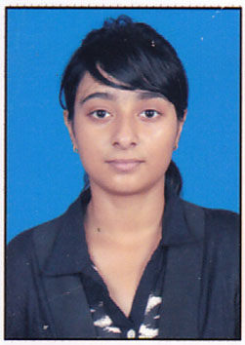ACADEMICS

Qualification | Institute | Board / University |  | Year | % / CGPA
B.Tech | Heritage Institute Of Technology | WBUT |  | 2022 | 8.05
XII | DPS Ruby Park Kolkata | CBSE |  | 2018 | 79%
X | Gokhale Memorial Girls’ School | State Board |  | 2016 | 77.5%
Electronics And Communication |  |  | ☒Full-Time  ☐Open-School  ☐Distance  ☐Correspondence
No. of active backlogs (Type NA if not applicable) |  |  | NA

CERTIFICATIONS / PUBLICATIONS
- British Council
- Flutter Under Ardent
- Introduction to Virtual Reality Under Coursera
- Basic Electronics Under NPTEL
- Digital electronics Under NPTEL

POSITIONS OF RESPONSIBILITY

Rotaract Club Of Calcutta Avyanna, 2021 | - Joint Treasurer Of Rotaract Club Of Calcutta Avyanna

EXTRA CURRICULAR ACTIVITIES

Dance

INTERNSHIPS
Webel | Internship on the topic Smart meter with a project
Final year project | Project on Solar Power Charged Controller Device

